We are so forgetful in fact, that this is the very reason why the inspired writer Luke records the practice of the Christians in the early church for us. Isn’t all of that worth celebrating more than just once a year? Paul, when describing how the Lord had handed him the Lord’s Supper, states it is a proclamation (1 Cor 11:26). Not just a proclamation of his death, but also of His glorious resurrection and His Lordship over all of those that have surrendered their lives to Him. Once a year? No thank you. Every first day of the week! HE LIVES!!
Curt

Sermon Questions
- When Mary arrives at the tomb she finds the stone _________ away.
- Which disciple reached the tomb first after Mary tells them Jesus is gone?
- Whom did Mary think was speaking to her while she was still there alone?
- Where is Jesus today?

Welcome

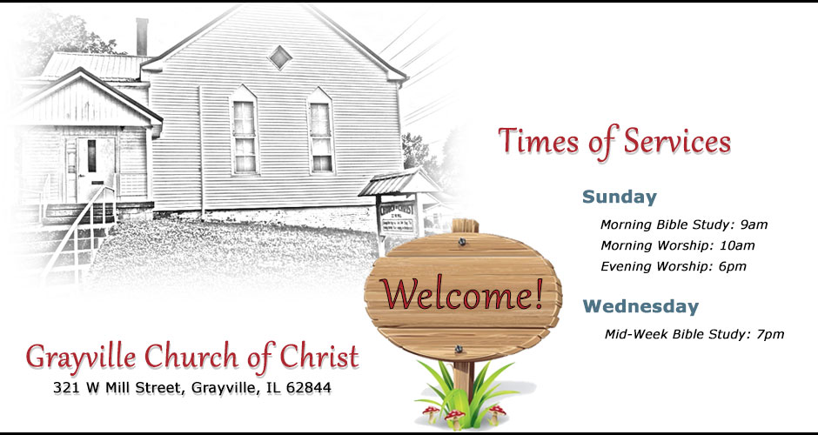

April 1, 2018
Men who will serve today
Announcements: Curt Hale
Song Leader: Jim Pringle
First Prayer: Troy Baxter
Second Prayer: Steve Hale
Lord’s Table: Chris Baxter, Leo Woods, Jim Mullinax
Closing Prayer: Jim Pringle

Prayer List
- Donna Nichols had successful surgery on her arm.
- Bro. Steve Hale will have foot surgery May 7th. The expected recovery time is 4-6 months.
- Bob and Lean will be traveling back from Texas today.
- Refer to Anna’s list for more.
Announcements
- Washington Avenue Church of Christ Ladies Day is upcoming. See the flyer on the back bulletin board for more information.
- John and Susie Orr will be back with us August 11-15. Plan to attend each opportunity they present us with. The topic will be Circle of Influence: How to meet prospects.
- Fellowship Meal April 8 right after morning services.
- Men’s business meeting April 15 5pm.

Ham and Eggs (Food for thought)
Every year, Easter rolls around and I always hear the same question. Where are you going to attend Easter services at? I suppose it’s a legitimate question to ask a person, however I feel most of the time the question is addressed in such as a way as to imply a person doesn’t go to church any other Sunday of the year. To be clear, I am not opposed to such an occasion set aside to celebrate the death, burial and resurrection of Jesus. I believe that anything that takes the focus off of this divisive world we live in and puts the focus on the Savior is in fact a good thing. But to be clear, the practice of Easter is not mentioned anywhere in the Bible.
But when I tell folks that I don’t celebrate Easter, their eyebrows immediately raise. Why wouldn’t you want to celebrate such a wonderful occasion they ask? And with a slight smile of satisfaction at the question, I say, “Glad you asked”.
Indeed, it is a very wonderful occasion to be celebrating. Celebrating a Savior who loved me and the rest of the human family enough to leave heaven and all of its glory, become a servant, and being motivated only by His love for God and bringing glory to Him and by doing so would give up His life for me and for you. Wonderful indeed!! Amen!! But also, that He ultimately was raised from the dead to demonstrate to all that He was in fact the Son of God with power. Amen again!! Wonderful indeed. So wonderful in fact, that Luke tells us in Acts 20:7 that the disciples came together every first day of the week to commune not only with one another, but also in fellowship together with our Lord and the breaking of bread. You remember, that Last Supper that Jesus shared with His chosen 12 the night before He died? It was through this institution, that one remembers exactly what the price was and still is to secure our salvation from sin and death. How easily we forget! We feeble human beings.

